**Java DB Conntetion**

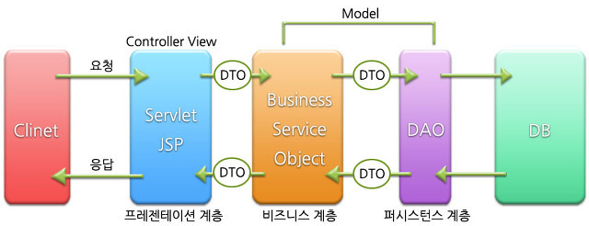

[결과]

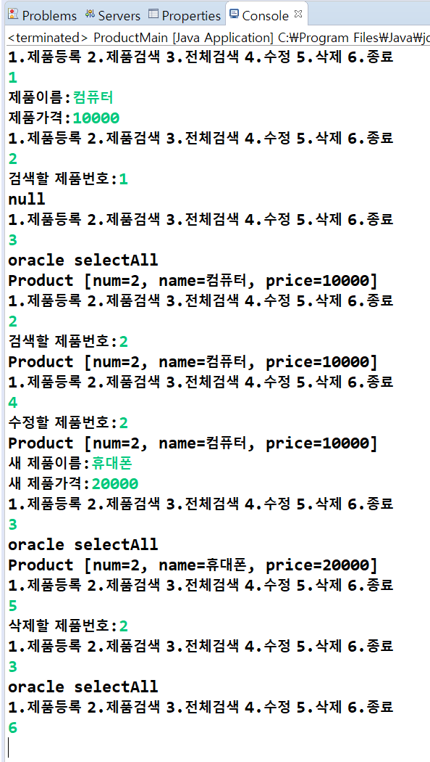

[product.sql]

|  |
| --- |
| --javalink/javalink  --sequence |

[Product.java]

|  |
| --- |
| **public** **class** Product {  **private** **int** num;  **private** String name;  **private** **int** price;    } |

[Dao.java]

|  |
| --- |
| **import** java.util.Vector;  **public** **interface** Dao {    **void** insert(Product p);  Product select(**int** num);  Vector<Product> selectAll();  **void** delete(**int** num);  **void** update(**int** num, Product p);  } |

[OracleDao.java]

|  |
| --- |
|  |

[Service.java]

|  |
| --- |
| **import** java.util.Vector;  **public** **interface** Service {  **void** addProduct();  **void** editProduct();  **void** delProduct();  Product getProduct();  Vector<Product> getProducts();  } |

[ServiceImpl.java]

|  |
| --- |
|  |

[DBConntection.java]

|  |
| --- |
| **import** java.sql.Connection;  **import** java.sql.DriverManager;  **public** **class** DBConnect {    **private** DBConnect() {        }  **public** **static** DBConnect getInstance() {  **return** *db*;  }  **public** Connection getConnection() {  **return** conn;  }  } |

[ProductMain.java]

|  |
| --- |
| **import** java.util.Scanner;  **import** java.util.Vector;  **public** **class** ProductMain {  } |